# IS 456 IT Database Systems Management

## HOP04 Basic SQLite Functions

4/13/2021 Developed by Farzin Bahadori

5/13/2021 Developed by Smita Dutta

School of Technology & Computing @ City University of Seattle (CityU)

### Before You Start

* The directory path shown in screenshots may be different from yours.
* Some steps are not explained in the tutorial**.** If you are not sure what to do:

1. Consult the resources listed below.
2. If you cannot solve the problem after a few tries, ask a TA for help.

### Learning Outcomes

Students will be able to:

* Understand the SQLite queries.
* Run queries in SQLite.
* Use inbuilt functions.

**-- 02 LENGTH**

**-- world.db**

SELECT LENGTH('string');

SELECT Name, LENGTH(Name) AS Len FROM City ORDER BY Len DESC;

**-- 03 SUBSTR**

**-- album.db**

SELECT SUBSTR('this string', 6);

SELECT SUBSTR('this string', 6, 3);

SELECT released,

SUBSTR(released, 1, 4) AS year,

SUBSTR(released, 6, 2) AS month,

SUBSTR(released, 9, 2) AS day

FROM album

ORDER BY released;

**-- 04 TRIM**

SELECT TRIM(' string ');

SELECT LTRIM(' string ');

SELECT RTRIM(' string ');

SELECT TRIM('...string...', '.');

**-- 05 UPPER/LOWER**

**-- world.db**

SELECT 'StRiNg' = 'string';

SELECT LOWER('StRiNg') = LOWER('string');

SELECT UPPER('StRiNg') = UPPER('string');

SELECT UPPER(Name) FROM City ORDER BY Name;

SELECT LOWER(Name) FROM City ORDER BY Name;

**-- 02 DATE/TIME functions**

**-- :memory:**

SELECT DATETIME('now');

SELECT DATE('now');

SELECT TIME('now');

SELECT DATETIME('now', '+1 day');

SELECT DATETIME('now', '+3 days');

SELECT DATETIME('now', '-1 month');

SELECT DATETIME('now', '+1 year');

SELECT DATETIME('now', '+3 hours', '+27 minutes', '-1 day', '+3 years');

**- 02 typeof**

SELECT TYPEOF( 1 + 1 );

SELECT TYPEOF( 1 + 1.0 );

SELECT TYPEOF('panda');

SELECT TYPEOF('panda' + 'koala');

**-- 03 INTEGER division**

SELECT 1 / 2;

SELECT 1.0 / 2;

SELECT CAST(1 AS REAL) / 2;

SELECT 17 / 5;

SELECT 17 / 5, 17 % 5;

**-- 04 ROUND()**

SELECT 2.55555;

SELECT ROUND(2.55555);

SELECT ROUND(2.55555, 3);

SELECT ROUND(2.55555, 0);

# Screenshots

Provide at least 3 screenshots as part of HOP submission.

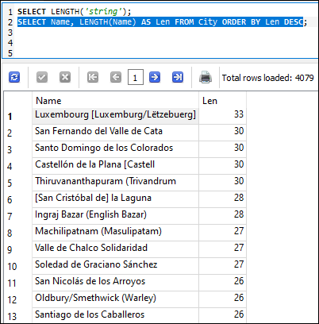

Figure ‑

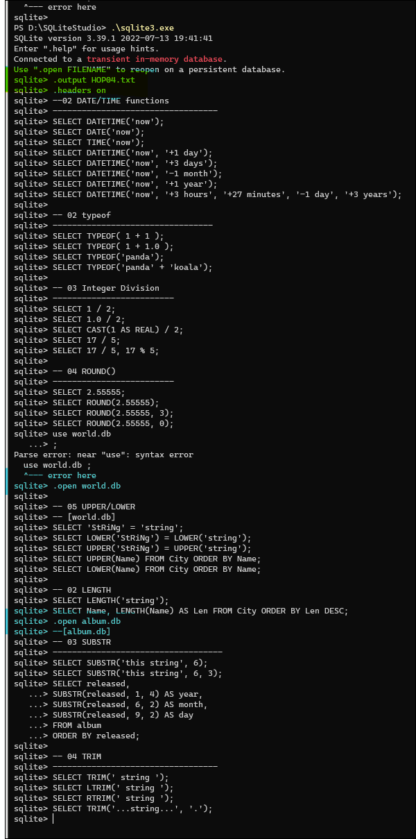

Figure ‑



Figure ‑



Figure ‑

Write a 150-word summary to explain your understandings and findings from this lab assignment.

In this assignment I’m not sure if anyone ever actually reads this. But I got the command line configured to except all the commands at once and write the results to a text file. I’m very proud of this. Next time I’ll add some code to it to make sure that the output is relevant to the query that called it in the first place.  
12000 lines of text is what was written to the file from the queries. That’s pretty crazy considering that two of those were 4000 lines a piece.

-Thad